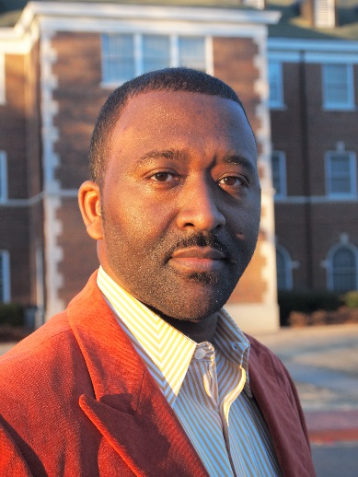
As a veteran educator, coach, and CEO of Parker Education & Development, LLC, Mr. Todd Scott Parker distinguishes himself through his ability to deliver dynamic educational coaching and professional development based on creating a stage—a foundation for facilitating positive interactions and quality relationships. He is driven to inspire educators and others to develop their talents and gifts to be prepared to teach and lead people from diverse backgrounds, cultures and histories. As an author, poet and energetic-inspirational speaker, Mr. Parker believes that young people, especially, deserve adults who are creative, skilled, experienced, and passionate about impacting their lives in a positive and profound way.
The flagship series of Parker Education & Development is the Relationship Management System (RMS). It is a system that includes four parts designed to promote relationship-driven teaching, behavioral guidance and discipline, increased academic performance, and effective communication and feedback strategies. The system is currently being used in diverse educational and workplace settings. Mr. Parker is also the creator of Kuu-Bro, a leadership initiative for young men and boys of color to establish their voice and cultivate their leadership skills. Most recently, he developed a student mentoring program called A Better Citizen (ABC) for alternative education environments in Arkansas. The program has received local and national attention. Mr. Parker has presented at numerous conferences across the country and is a standing guest speaker for teacher candidates at the University of Central Arkansas in Conway, Arkansas and Governor’s State University in University Park, Illinois. He is available for keynote presentations and trainings on demand.

