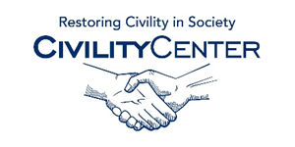Manners and Social Skills
Assessment links
Social Skills
http://www.do2learn.com/JobTIPS/DeterminingInterests/SocialSkillsAssessments/Assessments.html
http://www.selfesteem2go.com/social-skills-assessment.html
http://www.how-to-study.com/social-skills-assessment/
http://www.socialthinking.com/what-is-social-thinking/published-articles/98-assessment-of-social-cognition-and-related-skills-
http://communitygateway.org/resources/faq/social_skills/page5.htm

MANNERS
http://www.personalimpact.ca/self-assessments/self-assessment-manners-and-etiquette/
http://books.google.ca/books/about/Making_Manners_Matter_A_Manual_of_Manner.html?id=BqqF8L5wcvkC&redir_esc=y
http://www.thea4ideaplace.com/dining/dining-assessment-and-evaluation
http://www.scitronweb.com/free-assessment-tools-/telephone-skills-self-assessment
http://www.fomovancouver.com/good-manners-dont-take-much-effort/

