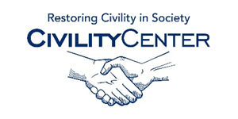Manners and Social Skills

Social Skills and Confidence Training

http://www.myvmc.com/treatments/social-skills-training-sst/
http://www.socialskillstrainingproject.com/
http://www.succeedsocially.com/grouptherapy
http://www.skillsyouneed.com/ps/confidence.html
http://www.businessballs.com/self-confidence-assertiveness.htm
http://www.iirmd.com/event/developing-professional-assertiveness-and-confidence
http://www.amanet.org/training/seminars/on-demand/Increasing-Your-Self-Confidence.aspx
http://www.skillpath.ca/index.cfm/on-site/seminar/topic/OS-Essentials-Credibility-Composure-Confidence
http://www.powerful-communication.com/confidence-building-coaching.htm
http://www.artofcommunicating.com.au/speak_confidence.html
http://attractioninstitute.com/confidence-training/

