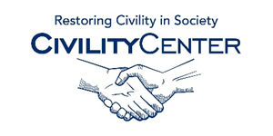Manners and Social Skills
Speakers
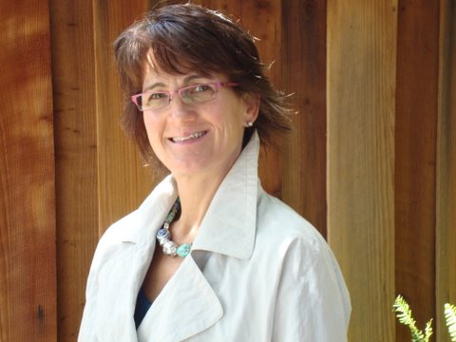

Speaker Region: | U.S., Canada, International
Speaker Focus:
 | Consultation and/or on-site customized trainings to schools, groups, and businesses
Michelle Garcia Winner is a speech language pathologist (SLP) who specializes in the treatment of students with social cognitive deficits at the Social Thinking Center, her clinic in San Jose, California. It was her interest in autism while attending the University of California, Santa Barbara, in 1979 that became the catalyst for becoming an SLP.
https://www.socialthinking.com/conferences/social-thinking-training-a-speakers-collaborative/speaker-bios/510-michelle-garcia-winner-ma-ccc-slp

Haviva Kranz
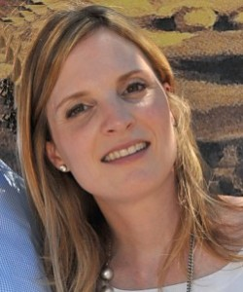Haviva Kranz is a New York State licensed speech-language pathologist with more than 15 years experience. She earned a Master’s Degree in Speech-Language Pathology and is ASHA certified (American-speech-language-Hearing Association). She has also completed the mentor-training program for “Social Thinking” created by Michelle Garcia Winner. In addition, she is trained in Verbal Behavior and in Lori Overland’s “Sensory Motor Approach to Feeding.” She has extensive professional experience working with children diagnosed with a wide variety of communication and related disorders including Autism spectrum disorders, oppositional defiance disorder, brain injuries, genetic syndromes and children with ADHD.
Haviva Kranz, SLP
Chari Siegel, SLP
366 Pearsall Avenue
Suite #8
Cedarhurst, NY 11516
516-239-3977
socialspeakers@gmail.com
Chari Siegel
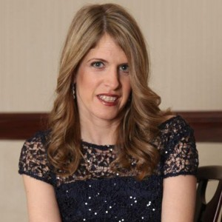Chari Siegel is a New York State and ASHA certified speech language pathologist who earned her MS in Speech-Language Pathology. Chari has extensive experience working with the pediatric population for over 15 years. Chari is a level -2 PROMPT trained therapist who has treated children with various speech and language delays/disorders including: receptive/expressive language delay, language processing disorders, apraxia, ADHD and autism. In addition, she is trained and utilizes the Beckman program for children who present with various oral motor deficits.
http://socialspeakersny.com/about-us/

Katrina Collier is an experienced social recruiting conference and event speaker, a regular interviewee and interviewer, and known for her warm and engaging style.http://www.winningimpression.com/social-recruitment-speaker/

Debbie Manners
Managing Director
Keo Films
Debbie is Managing Director at Keo Films and Chair of Pact Council. KEO is an integrated broadcast, commercial and digital production company that is regularly voted into the top few places in the Peer Polls for TV Indies. Developing and producing content that has something to say, and has a reason to exist beyond achieving ratings, the company's innovative approach has resulted in its programming becoming both ratings powerhouses and award winners. A fact well illustrated by the most recent production slate which includes Skint, a four part series for C4, Hugh’s Fish Fight, 2 series for C4 and Terry Pratchett: Choosing to Die, a one off documentary for BBC 2. KEO brings a strong, ethical brand reputation through its work and integration with Hugh Fearnley-Whittingstall, twice named Observer Campaigner of the Year, and the hugely successful River Cottage brand, now in it’s 14th iteration.
2008-2010 Chief Operating Officer at Hat Trick Productions
2006 - 2008 Group Commercial Director for RDF Media Group (now Zodiak)
2005 – 2006 Director of Rights, Flextech TV
1988-2005 Various BBC/BBC Worldwide business and commercial roles including latterly Director of Rights and Business Affairs, BBC
Speaking at: AMERICA 101
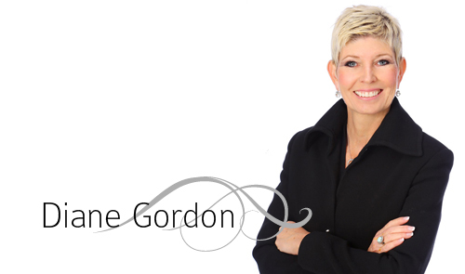
Diane Gordon
Founder of Etiquette Essentials
Certified as a Corporate Etiquette and International Protocol Consultant, Diane is more than an expert in good manners and etiquette – she builds confidence and success in every aspect of her clients’ lives.
Diane has come a long way from her childhood years where she was well known as a tomboy. When she moved into a new neighbourhood, she was actually mistaken for a boy! There was never a week without a bruised or cut knee and she earned the endearing nickname of “Tangle Foot” from her father.
But all that changed when her mother enrolled the budding etiquette expert into model and charm school at the age of twelve…and with her new-found confidence and determination she became unstoppable.
519.902.0867
dg@etiquetteessentials.ca
Contact Us

You May Contact Diane Gordon at

519.902.0867
dg@etiquetteessentials.ca
127 Wortley Rd.,
London, ON N6C 3P3

http://etiquetteessentials.ca/about-2/
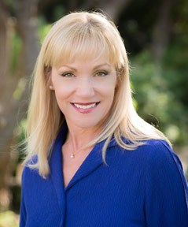
Deborah King, AICI CIP, CPC, CPECP is President of Final Touch Finishing School – the premier finishing school in the United States – which she founded in Seattle, Washington in 1989. Her passion is to equip people from all walks of life with the necessary skills to move confidently from the informal to the formal with ease and grace. She teaches how to evaluate each social and business circumstance, as well as how to respond with appropriate poise and manners based on a variety of cultural considerations. Deborah has over 35 years of experience in the civility, etiquette, and image industry. She is a certified protocol, etiquette and civility professional; a certified professional coach; and one of only 124 certified image professionals internationally. In 2010 she co-founded Global Protocol, Etiquette & Civility Academy in Dallas, Texas, and in 2012 she launched Etiquette and Lifestyle: Discovering and Exploring Savior Faire magazine.
http://finaltouchschool.com/about/deborah-king/

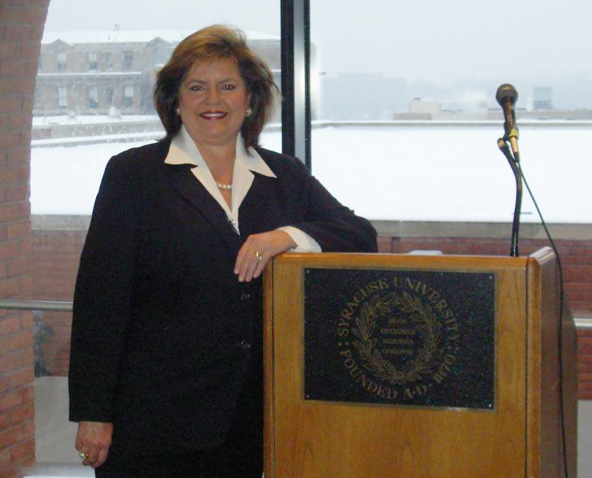
The Mission of Manners and Protocol, LLC is to present contemporary, universally accepted etiquette and protocol programs in the highest professional manner.
Margaret Ann Pritchard, Certified Corporate Etiquette and Protocol Consultant, has helped thousands of people across the United States to be more confident and courteous in business and social situations. She is founder of Manners and Protocol, LLC, a premier business etiquette consulting firm dedicated to assisting executives polish their professionalism, enhance their interpersonal skills, and improve their personal brand. For over a decade, Margaret Ann has been entertaining and training corporations, universities, and organizations across the United States. Her unique style and powerful presentations are recognized for world class enthusiasm, quality, and professionalism. You will laugh and you will learn. Results will be immediate, positive, and long-lasting.
http://www.mannersandprotocol.com/margaret-ann-pritchard/

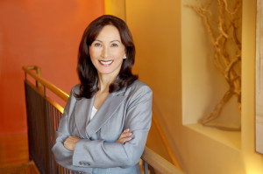
Lynda Jean is in the business of building confidence, transformation and supporting personalized goals for business and corporate success. With a background in clinical social work and college instruction, Lynda brings compassion, wisdom and energy to her current role of image consultant and corporate speaker. Lynda has made it her passion to work with individuals and corporations to elevate their presence to a professional level.
Lynda works individually with clients to show them how to create powerful first impressions so that they become more confident and successful in their work.
http://accessspeakers.biz/lynda-jean-image-consulting/

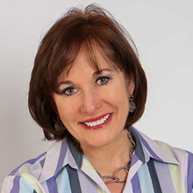
Lynne Breil, CSP
Pennsylvania, United States
"Lynne Breil is committed to developing great people skills for professionals. Lynne brings her message of personal polish and communication expertise to organizations internationally."
http://www.espeakers.com/marketplace/speaker/profile/13691/Lynne-Breil?resumeSearch=http%3A%2F%2Fwww.espeakers.com%2Fmarketplace%2Ftopics%2Ftopic%2F218%2FEtiquette

