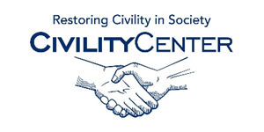Manners and Social Skills
Books
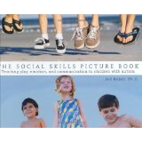
The Social Skills Picture Book: Teaching Communication, Play and Emotion
Jan 1 2001
by Jed Baker

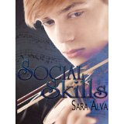
Social Skills
Jan 21 2013
by Sara Alva

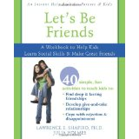
Let's Be Friends: A Workbook to Help Kids Learn Social Skills and Make Great Friends
May 15 2008
by Lawrence Shapiro

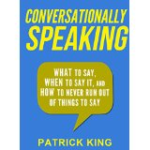
Conversationally Speaking: WHAT to Say, WHEN to Say It, and HOW to Never Run Out of Things to Say (Communication...
Feb 28 2015
by Patrick King

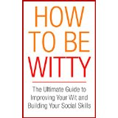
How To Be Witty: The Ultimate Guide to Improving Your Wit and Building Your Social Skills (Confidence Book 1)
Sep 28 2014
by Kerry Harding

The Shyness and Social Anxiety Workbook for Teens: CBT and ACT Skills to Help You Build Social Confidence
May 3 2012
by Jennifer Shannon and Christine Padesky

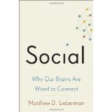
Social: Why Our Brains Are Wired to Connect
Oct 8 2013
by Matthew D. Lieberman

Manners
Apr 14 2004
by Kate Spade

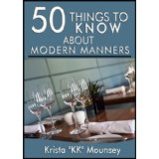
50 Things to Know About Modern Manners: Etiquette is a Way Of Life
Aug 13 2014
by Krista "KK" Mounsey and 50 Things To Know

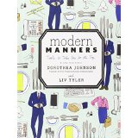

Modern Manners: Tools to Take You to the Top
Oct 29 2013
by Dorothea Johnson and Liv Tyler

