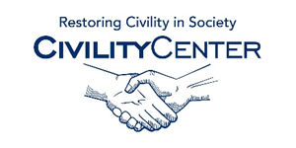Manners and Social Skills
Blogs
Manners
The Manners Blog
http://www.modern-manners-and-etiquette.com/manners-blog.html
Manners Mentor Blog
http://www.mannersmentorblog.com/
Etiquette Blog
http://www.practicaletiquette.com/etiquette-blog.html
Positively Positive
http://www.positivelypositive.com/2011/10/21/a-positive-attitude-the-essence-of-good-manners/
Manners a la Mode
http://mannersalamode.blogspot.ca/
Social Skills Blogs
Improve your social skills
http://www.improveyoursocialskills.com/social-skills-blog
Social Skills Central
http://socialskillscentral.com/category/blog/
Social Skills – Weekly Blog Spot
http://berriossocialskills.blogspot.ca/
Hometrain Group leaders Network – Blog
http://teachingcommunicationskills.blogspot.ca/
Michelles Blog – Social Thinking
https://www.socialthinking.com/what-is-social-thinking/michelles-blog

