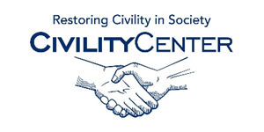Manners and Social Skills
Apps
11 Social Skills & Life Skills Apps in iPad App Store
Stories2Learn
Company: MDR
Category: Social Skills
Price: $13.99
Description: Stories2Learn offers parents and educators the ability to create personalized stories using photos, text, and audio messages. These stories can be used to promote an individual’s literacy, leisure, as well as social skills. With Stories2Learn an educator can quickly create a story that shows various social cues. For example, if an individual is learning a new concept such as turn taking, making improved eye contact, sharing, or other social messages, these concepts can be quickly depicted in a story created by parent or educator within minutes! The creator is able to add their own audio and write dialogue that corresponds to the photos.
Social Skills
Company: MDR
Category: Social Skills
Price: $6.99
Description: Social Skills offers parents and educators the ability to interact with six social narratives designed to help individuals improve their social ability. With Social Skills, the stories contain targeted instruction in the following core areas: Joint Attention; Non-Verbal Communication; Greetings; Structured game play; Turn Taking; Classroom rules; and Imitation. In addition to using the specific content, users can modify the stories by adding different photos, text, as well as audio. The end results allows for the individual to look at a social photo, touch the picture for audio, and continue onto the next page!
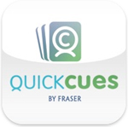QuickCues
Company: Fraser
Category: Social Skills
Price: $4.99
Description: QuickCues is a social script app that helps teens and young adults on the autism spectrum to handle new situations and learn new skills. Social scripts have been used successfully for years, but QuickCues makes these tools mobile and easy to use in everyday situations. With Quick Cues you can add four additional modules each priced at $4.99. The Communication module comes pre-installed and provides help with conversations at school or work, listening, and talking on the telephone. It also gives tips on reading body language and finding shared interests with others. Available for additional purchase via the In-App purchase are Life Skills Module, Socialization Module and the Coping Module.
Hidden Curriculum For Kids
Company: AAPC
Category: Social Skills
Price: $1.99
Description: Some people seem to learn the hidden curriculum almost automatically. Others learn it only by direct instruction. This includes children with autism spectrum disorders. These real-life based entries spur conversations about the countless “unwritten social rules” that we encounter every day and that can cause confusion and anxiety.
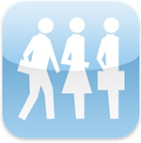Everyday Social Skills
Company: The Conover Company
Category: Social Skills
Price: $0.99
Description: The Everyday Social Skills application is designed to teach and reinforce basic social skills critical for independent living. For some, going on a shopping trip, using basic literacy skills, or understanding what to do when seeing a warning sign are very difficult tasks. The Everyday Social Skills application provides easy-to-understand information that allows users to become more capable of functioning independently at work, at home, and in the community. See also Responding Social Skills, Initiating Social Skills & Personal Social Skills.
Model Me Going Places
Company: Model Me Kids
Category: Life Skills
Price: Free
Description: Model Me Going Places™ is a great visual teaching tool for helping your child learn to navigate challenging locations in the community. Each location contains a photo slide show of children modeling appropriate behavior. Locations include: Hairdresser, Mall, Doctor, Playground, Grocery Store, Restaurant
Everyday Skills
Company: Ablelink Technologies
Category: Life Skills
Price: $49.99
Description: Everyday Skills provides self-directed learning sessions for 40 important skills necessary for living independently and accessing the community based on proven content developed by the Attainment Company. Everyday Skills provides an accessible learning tool that is specifically designed to be used directly by individuals with autism, learning or other developmental disabilities at their own pace on the coolest technology platform there is – the iPad! Everyday Skills is powered by Visual Impact, AbleLink’s highly effective cognitively accessible learning tool.
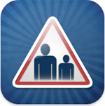Living Safely
Company: Ablelink Technologies
Category: Life Skills
Price: $34.99
Link: http://itunes.apple.com/us/app/living-safely/id396774523
Description: Living Safely provides self-directed learning sessions for 27 important safety skills topics. Living Safely provides an accessible learning tool that is specifically designed to be used directly by individuals with autism, learning or other developmental disabilities at their own pace on the coolest technology platform there is – the iPad!

