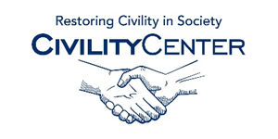Manners and Social Skills
Websites, Manners
http://www.missmanners.com/
http://www.mannersmentor.com/
http://www.cyborlink.com/
http://www.etiquetteguy.com/
http://lydiaramsey.com/
https://www.etiquettescholar.com/index.html
http://www.mannersmith.com/
http://www.educationworld.com/a_curr/curr232.shtml
http://etiquette-ny.com/
http://www.patriciarossi.com/
Websites, Social/Confidence Skills
http://socialskillscentral.com/
http://www.parentingscience.com/social-skills-activities.html
http://www.self-confidence.co.uk/articles/6-key-social-skills/
http://www.improveyoursocialskills.com/
http://www.succeedsocially.com/
https://shcs.ucdavis.edu/services/groups/social-confidence.html
http://www.confidenceunchained.com/
http://iameduard.com/
http://www.essentiallifeskills.net/buildself-confidence.html
http://ccl.ucsd.edu/registration/

