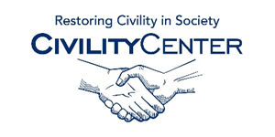**Civility and Leadership**

**Books**

* **[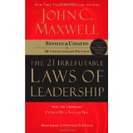](http://www.amazon.com/21-Irrefutable-Laws-Leadership-Anniversary/dp/0785288376/ref=sr_1_1?s=books&ie=UTF8&qid=1424994831&sr=1-1&keywords=Leadership)**

**[The 21 Irrefutable Laws of Leadership: Follow Them and People Will Follow You (10th Anniversary Edition)](http://www.amazon.com/21-Irrefutable-Laws-Leadership-Anniversary/dp/0785288376/ref=sr_1_1?s=books&ie=UTF8&qid=1424994831&sr=1-1&keywords=Leadership" \o "The 21 Irrefutable Laws of Leadership: Follow Them and People Will Follow You (10th Anniversary Edition))**

**Sep 16, 2007**

**by John C. Maxwell and Steven R. Covey**

* **[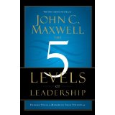](http://www.amazon.com/Levels-Leadership-Proven-Maximize-Potential/dp/1599953633/ref=sr_1_2?s=books&ie=UTF8&qid=1424994831&sr=1-2&keywords=Leadership)**

**[The 5 Levels of Leadership: Proven Steps to Maximize Your Potential](http://www.amazon.com/Levels-Leadership-Proven-Maximize-Potential/dp/1599953633/ref=sr_1_2?s=books&ie=UTF8&qid=1424994831&sr=1-2&keywords=Leadership" \o "The 5 Levels of Leadership: Proven Steps to Maximize Your Potential)**

**Sep 3, 2013**

**by** [**John C. Maxwell**](http://www.amazon.com/John-C.-Maxwell/e/B001H6NROC/ref=sr_ntt_srch_lnk_2?qid=1424994831&sr=1-2)

* **[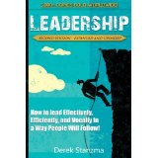](http://www.amazon.com/Leadership-Effectively-Efficiently-Vocally-Expanded/dp/1500829994/ref=sr_1_4?s=books&ie=UTF8&qid=1424994831&sr=1-4&keywords=Leadership)**

**[Leadership: How to Lead Effectively, Efficiently, and Vocally in a Way People Will Follow! Second Edition - Expanded...](http://www.amazon.com/Leadership-Effectively-Efficiently-Vocally-Expanded/dp/1500829994/ref=sr_1_4?s=books&ie=UTF8&qid=1424994831&sr=1-4&keywords=Leadership" \o "Leadership: How to Lead Effectively, Efficiently, and Vocally in a Way People Will Follow! Second Edition - Expanded and Updated!)**

**Aug 16, 2014**

**by** [**Derek Stanzma**](http://www.amazon.com/Derek-Stanzma/e/B00HRRI2IG/ref=sr_ntt_srch_lnk_4?qid=1424994831&sr=1-4)

* **[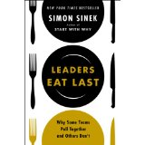](http://www.amazon.com/Leaders-Eat-Last-Together-Others/dp/1591845327/ref=sr_1_5?s=books&ie=UTF8&qid=1424994831&sr=1-5&keywords=Leadership)**

**[Leaders Eat Last: Why Some Teams Pull Together and Others Don’t](http://www.amazon.com/Leaders-Eat-Last-Together-Others/dp/1591845327/ref=sr_1_5?s=books&ie=UTF8&qid=1424994831&sr=1-5&keywords=Leadership" \o "Leaders Eat Last: Why Some Teams Pull Together and Others Don’t)**

**Jan 7, 2014**

**by** [**Simon Sinek**](http://www.amazon.com/Simon-Sinek/e/B002CB2SDC/ref=sr_ntt_srch_lnk_5?qid=1424994831&sr=1-5)

* **[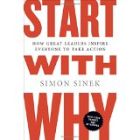](http://www.amazon.com/Start-Why-Leaders-Inspire-Everyone/dp/1591846447/ref=sr_1_6?s=books&ie=UTF8&qid=1424994831&sr=1-6&keywords=Leadership)**

**[Start with Why: How Great Leaders Inspire Everyone to Take Action](http://www.amazon.com/Start-Why-Leaders-Inspire-Everyone/dp/1591846447/ref=sr_1_6?s=books&ie=UTF8&qid=1424994831&sr=1-6&keywords=Leadership" \o "Start with Why: How Great Leaders Inspire Everyone to Take Action)**

**Dec 27, 2011**

**by** [**Simon Sinek**](http://www.amazon.com/Simon-Sinek/e/B002CB2SDC/ref=sr_ntt_srch_lnk_6?qid=1424994831&sr=1-6)

* **[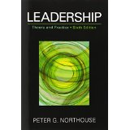](http://www.amazon.com/Leadership-Practice-Peter-G-Northouse/dp/1452203407/ref=sr_1_8?s=books&ie=UTF8&qid=1424994831&sr=1-8&keywords=Leadership)**

**[Leadership: Theory and Practice, 6th Edition](http://www.amazon.com/Leadership-Practice-Peter-G-Northouse/dp/1452203407/ref=sr_1_8?s=books&ie=UTF8&qid=1424994831&sr=1-8&keywords=Leadership" \o "Leadership: Theory and Practice, 6th Edition)**

**Feb 2, 2012**

**by Peter G. Northouse**

* **[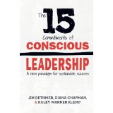](http://www.amazon.com/15-Commitments-Conscious-Leadership-Sustainable/dp/0990976904/ref=sr_1_11?s=books&ie=UTF8&qid=1424994831&sr=1-11&keywords=Leadership)**

**[The 15 Commitments of Conscious Leadership: A New Paradigm for Sustainable Success](http://www.amazon.com/15-Commitments-Conscious-Leadership-Sustainable/dp/0990976904/ref=sr_1_11?s=books&ie=UTF8&qid=1424994831&sr=1-11&keywords=Leadership" \o "The 15 Commitments of Conscious Leadership: A New Paradigm for Sustainable Success)**

**Jan 10, 2015**

**by** [**Jim Dethmer**](http://www.amazon.com/Jim-Dethmer/e/B00R4TTGC8/ref=sr_ntt_srch_lnk_11?qid=1424994831&sr=1-11) **and** [**Diana Chapman**](http://www.amazon.com/Diana-Chapman/e/B00RKLDW6Q/ref=sr_ntt_srch_lnk_11?qid=1424994831&sr=1-11)

* **[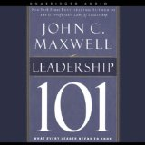](http://www.amazon.com/Leadership-101-Every-Leader-Needs/dp/B002WJG2OK/ref=sr_1_10?s=books&ie=UTF8&qid=1424994831&sr=1-10&keywords=Leadership)**

**[Leadership 101: What Every Leader Needs to Know](http://www.amazon.com/Leadership-101-Every-Leader-Needs/dp/B002WJG2OK/ref=sr_1_10?s=books&ie=UTF8&qid=1424994831&sr=1-10&keywords=Leadership" \o "Leadership 101: What Every Leader Needs to Know)**

**Nov 11, 2009 | Unabridged**

**by John C. Maxwell and Sean Runnette**

* **[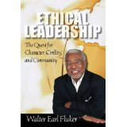](http://www.amazon.com/Ethical-Leadership-Character-Civility-Community/dp/0800663497/ref=sr_1_1?s=books&ie=UTF8&qid=1424995364&sr=1-1&keywords=Leadership+civility)**

**[Ethical Leadership: The Quest for Character, Civility, and Community (Prisms) (Prisms)](http://www.amazon.com/Ethical-Leadership-Character-Civility-Community/dp/0800663497/ref=sr_1_1?s=books&ie=UTF8&qid=1424995364&sr=1-1&keywords=Leadership+civility" \o "Ethical Leadership: The Quest for Character, Civility, and Community (Prisms) (Prisms))**

**Feb 1, 2009**

**by Walter Earl Fluker**

* **[](http://www.amazon.com/Youre-not-only-this-Planet/dp/1418420328/ref=sr_1_4?s=books&ie=UTF8&qid=1424995364&sr=1-4&keywords=Leadership+civility)**

**[You're not the only one on this Planet!: Observations on the absence of Civility: A Book of Leadership](http://www.amazon.com/Youre-not-only-this-Planet/dp/1418420328/ref=sr_1_4?s=books&ie=UTF8&qid=1424995364&sr=1-4&keywords=Leadership+civility" \o "You're not the only one on this Planet!: Observations on the absence of Civility: A Book of Leadership)**

**May 5, 2004**

**by John Mayer**

In this absorbing tale, you watch the timeless principles of servant leadership unfold through the story of John Daily, a businessman whose outwardly successful life is spiraling out of control. He is failing miserably in each of his leadership roles as boss, husband, father, and coach. To get his life back on track, he reluctantly attends a weeklong leadership retreat at a remote Benedictine monastery.  
  
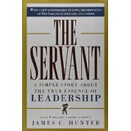

# The Servant: A Simple Story About the True Essence of Leadership Hardcover – September 1, 1998

by [James C. Hunter](http://www.amazon.com/James-C.-Hunter/e/B001K8RWMA/ref=dp_byline_cont_book_1) (Author)