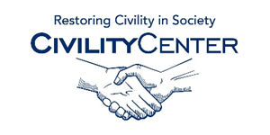Civility and Leadership
Blogs
Leadership blogs from HBR.org
http://www.harvardbusiness.org/leadership-blogs-hbrorg
Leadership now
http://www.leadershipnow.com/leadingblog/
Ken Blanchard Leadership Blogs
http://www.kenblanchard.com/Leading-Research/Blog
Great Leaders Serve
http://greatleadersserve.com/
Coaching Tip: The Leadership Blog
http://www.coachingtip.com/
The Leadership Hub
http://www.theleadershiphub.com/best-leadership-blogs
Three Star Leadership
http://www.threestarleadership.com/blog
Linked 2 Leadership
http://linked2leadership.com/
Leader Values
http://www.leader-values.com/wordpress/
The Advancing Leadership Blog
http://blog.tec-canada.com/

