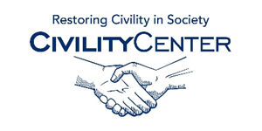Civility and Leadership
Assessment Links
http://www.kellogg.northwestern.edu/faculty/uzzi/htm/teaching-leadership.htm
http://www.leadershipchallenge.com/leaders-section-assessments.aspx
http://www.mindtools.com/pages/article/newLDR_01.htm
http://www.yourleadershiplegacy.com/assessment.html
https://www.theleadershipcircle.com/assessment-tools
http://8dimensionsofleadership.com/the-assessment/
http://www.ccl.org/Leadership/assessments/assessment360.aspx
http://www.studentleadershipchallenge.com/Assessments.aspx
http://www.ddiworld.com/expertise/leadership-development/leadership-assessment
http://www.kenblanchard.com/Solutions/Assessments

