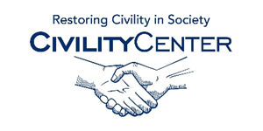Civility and Leadership
Apps and Videos

- Article about 20 iPhone Apps GREAT FOR Leaders: https://www.linkedin.com/pulse/20130910143311-13518874-iphone-5s-launch-the-killer-apps-for-leaders

- World Of CEOs
If you’re a CEO, or want to learn about peers and connect with them, or become one yourself, then World Of CEOs is the destination site. Its customizable CEO Dashboard App enables you to monitor breaking CEO stories, videos and must-read CEO relevant thought leadership pieces. You can monitor the CEO conversation on Twitter, and explore 4,500 in-depth CEO Dossiers to learn about their career stories and leadership styles and philosophies.

- Leadership Skills
Springz
- November 13, 2014
Lifestyle
Leadership and management skills are indications of your potential in the company.
So Try this app and be confident

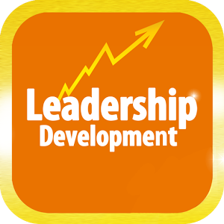
- Leadership Development
Smart Media Innovations Pty Ltd
- October 22, 2014
Business
This Leadership Development app features the latest discussions, webinars and topics surrounding Leadership skills training and development from our featured experts, coaches and publishers

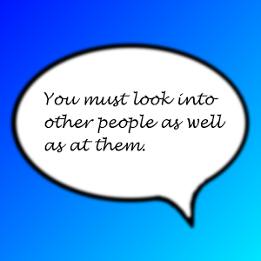
- Leadership Quotes
SusaSoftX
- June 8, 2014
Business
Leadership is activity by which people become aware of ways to accomplish their desired goals and to develop new values and goals which are in greater accord with their current capacities and ultimate potentials

- Secrets of Success
Dale Carnegie Training
- July 2, 2013
Business
Now one of the top selling paid business apps!!--Carry a Carnegie Coach in your pocket to help you engage with clients, prospects, peers and management anytime, anywhere.
Need to motivate your team – click on “Be a Leader” and see how the pros do it. Do you have conflict in the department – click on “Gain Cooperation” to see the right way to get everyone rowing in the same direction. Need to enhance your relationships– watch the wrong way and then the right way to build trust. You’ll find secrets of success to be your indispensible pocket coach every time you face one of those tough “people issues.”

- Synopsis | Nobility And Civility: Asian Ideals Of Leadership And The Common Good
https://www.youtube.com/watch?v=IMK8xwU7-hY
- Civility and respect
https://www.youtube.com/watch?v=Nzt3WCSuVc8
- The 5 Levels of Leadership
https://www.youtube.com/watch?v=aPwXeg8ThWI
- Why Leaders eat Last
https://www.youtube.com/watch?v=ReRcHdeUG9Y
- Simon Sinek – Love Your Work
https://www.youtube.com/watch?v=jDIZS4IQlQk
- Serving Those Who Serve Others
https://www.youtube.com/watch?v=_8-dhTodlKI

