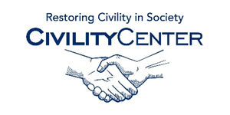Civility in the community

On Ethics, Rhetoric and Civility: A Response to Professor Frankel
Posted by Harvey L. Pitt, Kalorama Partners, LLC, on Monday January 19, 2015 at 11:04 am
http://blogs.law.harvard.edu/corpgov/2015/01/19/on-ethics-rhetoric-and-civility-a-response-to-professor-frankel/

THE CIVILITY BLOGS
http://www.forest.edu/cr-cich-civility/the-civility-blogs.aspx

Civility 101
http://blogs.berkeley.edu/2011/01/17/civility-101/
FSCJ Civility Campaign
https://blogs.fscj.edu/civility/
Evaluation is an everyday activity
http://blogs.oregonstate.edu/programevaluation/2013/09/17/community-civility-compassion-comfort/
Call for civility in the blogosphere
http://uaecommunity.blogspot.ca/2007/04/nyt-call-for-civility-in-blogosphere.html
The Neurobiology of Civility
http://www.boston.com/community/blogs/human_nature/2011/01/the_neurobiology_of_civility.html

Confessions of a community college dean
https://www.insidehighered.com/blogs/confessions_of_a_community_college_dean/civility

Principles of Civility and Community
http://civility.utk.edu/

Civility and the Possibility of Community
http://www.patheos.com/blogs/homewaters/2012/09/civility-and-the-possibility-of-community.html

