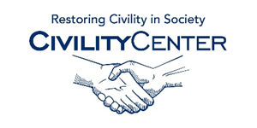Civility and Community
Books

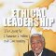
Ethical Leadership: The Quest For Character, Civility, And Community Paperback – Feb 1 2009
by Walter Fluker (Author)

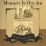
Civility & Community Audio CD – Jul 1 2006
by Robert Guillaume (Narrator)

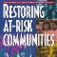
Restoring At - Risk Communities: Doing It Together and Doing It Right Paperback – Nov 1 2011
by John Perkins (Editor)

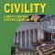
Civility: How It Fosters Better Communities Paperback – Jun 2003
by Godfrey Harris (Author)

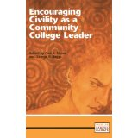

Encouraging Civility as a Community College Leader
by Paul A. Elsner and George R. Boggs

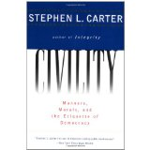

Civility
by Stephen Carter

Cosmospolitan Canopy,The: Race And Civility In Everyday Life
by Elijah Anderson

The Courage to Teach: Exploring the Inner Landscape of a Teacher's Life
by Parker J. Palmer

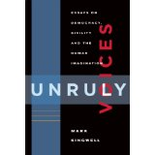

Unruly Voices: Essays on Democracy, Civility and the Human Imagination
by Mark Kingwell

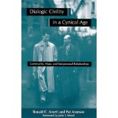

Dialogic Civility in Cynical Age: Community, Hope, and Interpersonal Relationships
by Ronald C. Arnett and Pat Arneson

