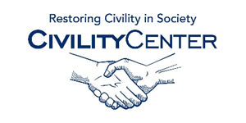Civility at work
Blogs
The importance of Civility in the Workplace
http://smallbusiness.chron.com/importance-civility-workplace-43590.html
Work shouldn’t hurt
http://www.extension.iastate.edu/mt/civility/relationships/bullying/
The respectful workplace blog
http://legacycultures.com/blog/
SmartBlog
http://smartblogs.com/leadership/2013/01/29/can-leaders-demand-civility/
Choosing civility in a rude culture
http://blog.spiritualityandpractice.com/blog/civility-spirituality/choosing-civility-in-a-rude-culture
E.L.I Build a civil workplace
http://www.eliinc.com/blog/
Reclaim Workplace Civility
http://www.ttisuccessinsights.com/blog/posts/reclaim-workplace-civility-through-personal-leadership
The emerging implied sense of Decency
http://lawofwork.ca/?p=971
Now’s a great time for workplace Civility initiatives
http://www.delawareemploymentlawblog.com/2009/07/nows-a-great-time-for-workplac.html
Civility Matters: The power of “Thank You”
http://www.obj.ca/Blog-Article/b/20450/Civility-matters-The-power-of-thank-you

