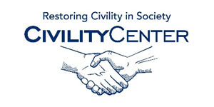Civility at School

YouTube Civility in school Videos
Choosing Civility in the Real World – YouTube
https://www.youtube.com/watch?v=ac9VidPJMco
Tepper School Research – Workplace Civility
https://www.youtube.com/watch?v=eYawveB8C_A
Our Lady of Perpetual Help School Choose Civility Award for Individual School
https://www.youtube.com/watch?v=CjD438jz4p8
Warren R. Paboojian of Baradat & Paboojian "Civility Matters" Lecture (Law School)
https://www.youtube.com/watch?v=sAWO8IiuhSg
Howard County Public School System Choose Civility Award for Outstanding Educational Institution
https://www.youtube.com/watch?v=fTdrp4TMqww
Nine Academy | Civility and Democracy | After School Lessons
https://www.youtube.com/watch?v=GwrU-eK1jUI
Introducing "A Culture of Civility" - Preventing Identity-Based Bullying
https://www.youtube.com/watch?v=dCPV2y25cNw
Civility Selfie Challenge
https://www.youtube.com/watch?v=e25neTs12HQ
How Can Parents Teach Empathy to Prevent Bullying? A Culture of Civility Parent Dialogues
https://www.youtube.com/watch?v=dJEpUXhkiQw
How Can Parents Collaborate with Teachers to Prevent Bullying? A Culture of Civility
https://www.youtube.com/watch?v=IbJWI6zTwDk

