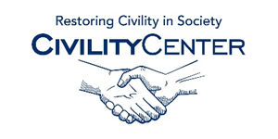Civility at School

Civility at school speakers
Mary Bixby
Learning Resource Specialist, The Learning Center
PHONE: 573-881-5858 (cell / local)
E-MAIL: BixbyM@missouri.edu
Topics:
Partner benefits, diversity in the classroom, and LGBT issues
Lea Cheyney Brandt
Clinical Assistant Professor and Associate Director,
MU Center for Health Ethics
PHONE: 573-884-5576
E-MAIL: BrandtLC@health.missouri.edu
Topics: Ethics and professionalism
Karen Harris
Director, Patient and Family-Centered Care, MU Health Care
PHONE: 573-882-2235 or 573-808-0036
E-MAIL: HarrisKD@health.missouri.edu
Topics:
In my role at MUHC, I am responsible for developing and implementing strategies across the organization to promote a patient-centered environment. This involves working closely with faculty and staff to teach communication skills and relationship-based care and the impact this has on not only the patient and family but faculty and staff. I currently teach patient and family-centered care(PFCC) at new staff orientation for both employees and faculty (attending, fellows and residents) I provide presentations to outside organizations such as Missouri League of Nursing and Human Resources Association providing topics related to conflict resolution, customer service, communication and service recovery.

James Hunter
Director, Employee Assistance Program
PHONE: 573-882-6701
E-MAIL: HunterJD@missouri.edu
Topics:
Civility and incivility in the workplace
Frankie Minor
Director, Residential Life
PHONE: 573-882-7275
E-MAIL: Frankie@missouri.edu
Topics:
Experience in helping promote civility/community responsibility in residential settings; initially pitched, promoted and involved in the creation of the institutional values, including Respect and Responsibility.
Lisa Zanetti
Associate Professor, Truman School of Public Affairs
PHONE: 573-424-1857 (cell)
E-MAIL: ZanettiL@missouri.edu
Topics:
Empathy as a public and private value. Mental health and invisible disabilities. I have bipolar disorder, fibromyalgia and chronic migraines. I am quite public about these and in fact sit on the City of Columbia's Disabilities Commission to represent invisible disabilities.
Lee Wilkins
Curator's Teaching Professor, Missouri School of Journalism
E-MAIL: WilkinsL@missouri.edu
Topics:
Media ethics
Jim Leach
Jim Leach, chairman of the National Endowment for the Humanities, gives a Clinton School lecture titled, "Civility in a Fractured Society," about the danger that stridency poses to open debate and compromise in America’s democracy. Leach is the ninth chairman of the NEH, which is an independent grant-making agency of the U.S. government dedicated to supporting research, education, preservation and public programs in the humanities.

Dr. Cornell W. Clayton
Director, Thomas S. Foley Institute for Public Policy and Public Service, Washington State University
Cornell Clayton is Director of the Thomas S. Foley Institute of Public Policy and Public Service, and C.O. Johnson Distinguished Professor of Political Science, at Washington State University. Dr. Clayton received his B.A. in political science from the University of Utah, and his Master’s and Doctoral degrees inpolitics from Oxford University. The author or editor of seven books and numerous journal articles and book chapters, Professor Clayton currently serves as Editor of Political Research Quarterly, the journal of the Western Political Science Association. His recent book, Civility and American Democracy (co-edited with Richard Elgar), was published last year and is the product of a major scholarly conference examining the relationship between civil behavior and democratic governance organized by the Foley Institute and funded through a quarter-million dollar grant from the National Endowment for the Humanities. Among Professor Clayton many distinctions, he has twice been a Fulbright Scholar, and held fellowships at the European Union Institute in Florence, the Salzburg Institute in Austria, the Miller Center for Politics at the University of Virginia, and this coming year will hold the Wayne N. Aspinall Distinguished Visiting Chair at Colorado Mesa University.
Dr. Bertie Simmons
Principal, Furr High School, Houston, Texas
Dr. Bertie Simmons has been an educator for 48 years, holding numerous positions within the Houston Independent School District. Since 2000, she has been the principal at Furr High School, and in that role has turned the school and its student body around from one of hopelessness, violence, and fear to one of creativity, determination and achievement. Dr. Simmons was recently recognized for her work when she received the Texas State HEB Secondary Principal of the Year Award in 2009, the most recent in a long line of recognitions.

References:
http://civility.missouri.edu/speakers-bureau.php
http://clintonschoolspeakers.com/lecture/view/civility-fractured-society
http://www.instituteforcivility.org/citizens-civility-symposium-2013/speakers/

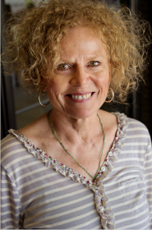
Patty Kohler, Ed. D., is an associate professor at the University of Central Arkansas in the Department of Elementary, Literacy, and Special Education. As a former teacher, she has worked with students with disabilities for over thirty years. She has nineteen years of experience as a special education administrator in the largest district in Arkansas, serving urban students with numerous needs stemming from poverty, disability, and race. While there, she focused on inclusive education and making sure that the needs of all students were met. During her tenure in Little Rock, the district co-hosted the state’s first conference on inclusive education.

Dr. Kohler’s research interests include inclusive education and meeting the needs of all students in various settings. She is the co-author of Civility, Compassion and Courage in Schools Today: Strategies for Implementing in K-12 Schools and Meaningful Conversations: The Way to Comprehensive and Transformative School Improvement. The 3 C’s promotes teaching civility, compassion and courage in schools, homes and in the community using the Model of Influence—a framework for that moves from awareness to action. Training for the 3C’s is available on demand. She has also numerous published articles on co-teaching, the importance of developing positive relationships with students as well as teachers. She serves as an Executive Coach for the Little Rock School District. Dr. Kohler is also a consultant for Parker Education & Development, LLC, and is available for keynote presentations and coaching sessions.

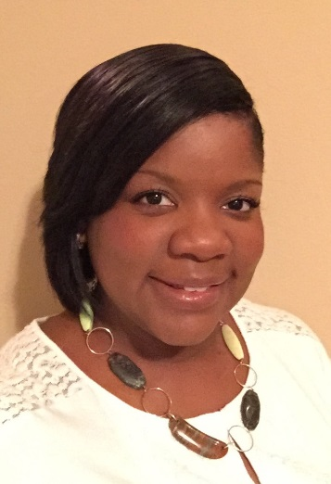
Candice Dowd Barnes, Ed.D., is an assistant professor at the University of Central Arkansas in the department of Elementary, Literacy and Special Education. She is also the Chief Operations Officer for Parker Education & Development, LLC. Parker Education & Development, LLC offers professional development and educational coaching using unique Edutainment activities to promote effective relationships and interactions with students, parents, co-workers and colleagues. She strongly believes in the power of authentic learning experiences to teach beyond the walls of the classroom into all aspects of life.
Dr. Barnes has an extensive background in early childhood education, curriculum and assessment planning, and educational leadership. She is a dynamic speaker and accomplished author of multiple articles on developing authentic relationships and interactions with, and dispositions of, individuals of diverse and unique backgrounds and histories. Most recently, she co-authored Civility, Compassion and Courage in Schools Today: Strategies for Implementing in K-12 Classrooms. The 3 C’s promotes teaching civility, compassion and courage in schools, in homes and in the community using the Model of Influence—a framework for that moves from awareness to action. Training on the Model and the 3C’s is available on demand. She has presented across the country on various topics related to service-learning, social and emotional development, effective leadership and coaching, curriculum integration and assessment planning, and teaching disposition development from the classroom to the workplace. Dr. Barnes is also available for keynote presentations and coaching sessions.

