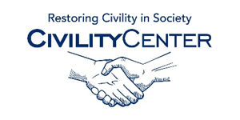Civility and family

Civility and family/home Speakers
Judy the manners lady
http://themannersclub.com/?page_id=7
The Manners Lady
Vancouver, BC
Canada
Phone: 1-866-ASK-JUDI

Deborah King
http://finaltouchschool.com/about/deborah-king/
(206) 510-5357

Benet Davetian
http://www.keynotespeakerscanada.ca/speaker/benet-davetian
Hon. Angela M. Ordoñez
Chief Justice
Massachusetts Probate and Family Court
Paul M. Kane
McGrath & Kane
Norman Jacobs
https://www.bostonbar.org/membership/events/event-details?ID=15788

Emmanuel Agius
What Future for Future Generations?
Our Responsibilites Towards Future Generations
The Rights of Future Generations
Daniel M. Boland PHD
Taking Responsibility & Staying Accountable for Your Life at Work & Family
http://www.wcspeakers.com/speakers-bureau.cfm?search_topic=Life%20Skills%20%2F%20Ethics%20%2F%20Integrity%20%2F%20Civility%20%2F%20Character
Extras:
http://news.vanderbilt.edu/2014/03/care-kickoff-workplace-civility/
http://wheatley.byu.edu/fellow_notes/individual.cfm?id=1
http://www.law.ufl.edu/flalaw/2012/04/professionalism-symposium-speaker-greatest-problem-is-injustice-not-incivility/
http://www.portlandlibrary.com/highlight/choose-civility/

