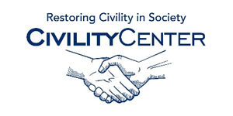Civility and Community

Websites

Coalition for a Better Community
http://coalitionforabettercommunity.org/default.asp?iId=GDEDGF

The Oshkosh Civility Project
http://www.oshkoshcivilityproject.org/

Restoring Respect
http://www.sandiego.edu/restoringrespect/

Nassau Community College Civility Library
http://ncc.libguides.com/content.php?pid=530279&sid=4368221

Rutgers Project Civility
http://projectcivility.rutgers.edu/ambassadors

Fund for Civility
http://fundforcivility.org/about-us/
Building Common Ground
http://ppo.ala.org/commonground/
Good Character
http://www.goodcharacter.com/TeacherResources.html

Breakpoint Commentaries
http://www.breakpoint.org/bpcommentaries/entry/13/26421
RaceBridges For Schools
http://racebridgesforschools.com/wp/?p=2860

