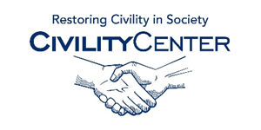**Civility and Community**

**Apps and Other**

A Call For Civility  
<http://civility.utk.edu/video.php>  
  
Civility in the legal community  
<https://vimeo.com/89976983>   
  
Toward Civility – A community vision  
<https://vimeo.com/16620653>

Community Nashville - “The loss of civility”  
<https://www.youtube.com/watch?v=hTjLarvLHVw>

What is Civility?  
<https://www.youtube.com/watch?v=zfKzNCKpGPM>  
  
“I believe in fairness and civility”   
<https://vimeo.com/53055026>

Glendale community college – Civility in Action  
<https://www.youtube.com/watch?v=EA6tV0wi8mo>   
  
Religion and Public Civility  
<http://www.c-span.org/video/?298360-3/religion-public-civility>

Choosing Civility  
<https://www.youtube.com/watch?v=d4uCYoq15T4>   
  
Is Public Civility Gone?  
<https://www.youtube.com/watch?v=KLi6zMUF61o>