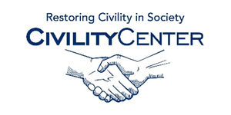Civility around the World

Cultural Civility Books

http://www.harpercollins.com/9780061353437/the-case-for-civility
About the Book
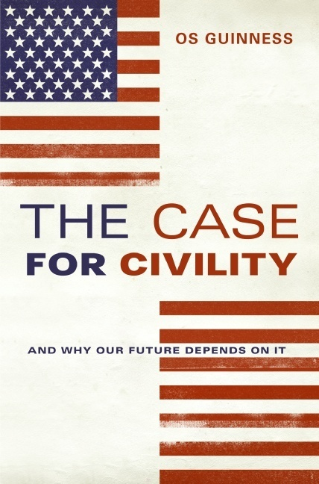
In a world torn apart by religious extremism on the one side and a strident secularism on the other, no question is more urgent than how we live with our deepest differences—especially our religious and ideological differences. The Case for Civility is a proposal for restoring civility in America as a way to foster civility around the world. Influential Christian writer and speaker Os Guinness makes a passionate plea to put an end to the polarization of American politics and culture that—rather than creating a public space for real debate—threatens to reverse the very principles our founders set into motion and that have long preserved liberty, diversity, and unity in this country.

Guinness takes on the contemporary threat of the excesses of the Religious Right and the secular Left, arguing that we must find a middle ground between privileging one religion over another and attempting to make all public expression of faith illegal. If we do not do this, Guinness contends, Western civilization as we know it will die. Always provocative and deeply insightful, Guinness puts forth a vision of a new, practical "civil and cosmopolitan public square" that speaks not only to America's immediate concerns but to the long-term interests of the republic and the world

http://www.amazon.ca/Civility-Cultural-History-Benet-Davetian/dp/0802097227
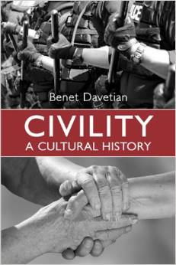
Cut off in traffic? Bumped without apology on the subway? Forced to listen to a profane conversation in a public space? In today's Western societies, many feel that there has been a noticeable and marked decrease in mutual consideration in both public and private settings. Are we less civil now than in the past? Benet Davetian's masterful study Civility: A Cultural History responds to this question through a historical, social, and psychological discussion of the civility practices in three nations - England, France, and the United States.
Davetian's rich, multi-dimensional review of civility from 1200 to the present day provides an in-depth analysis of the social and personal psychology of human interaction and charts a new course for the study and understanding of civility and civil society. Civility addresses major topics in public discourse today regarding the ideals and practices of civility and the possibility of a future civility ethic capable of inspiring cooperation across cultural and national boundaries.

http://www.barnesandnoble.com/w/managing-cultural-differences-robert-t-moran/1120733518?ean=9780415717359
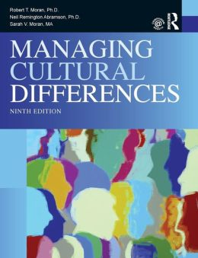
The world of business for all organizations in the twenty-first century is global, interdependent, complex, and rapidly changing. That means sophisticated global leadership skills are required more than ever today. Individual and organizational success is no longer dependent solely on business acumen. Our ability to understand, communicate, and manage across borders, countries, and cultures has never been as important as it is now. The understanding and utilization of cultural differences as a business resource is a key building block as companies rely on their global reach to achieve the best profit and performance.

http://www.barnesandnoble.com/w/its-okay-to-be-different-todd-parr/1100716781?ean=9780316043472
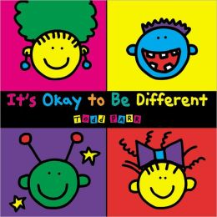
Featuring Todd Parr's trademark bold, bright colors and silly scenes, this book embraces difference in a unique way. Deceptively simple in appearance, It's OK to Be Different cleverly delivers its important messages of acceptance, understanding, and confidence in a child-friendly package.
Author Biography: Todd Parr's previous books have been praised by critics and his designs appear on clothing, furniture, toys, and other products for children. He lives in San Francisco.
Illustrations and brief text describe all kinds of differences that are "okay," such as "It's Okay to be a different color," "It's Okay to need some help," "It's Okay to be adopted," and "It's Okay to have a Different nose."

http://www.barnesandnoble.com/w/peoples-cultures-biography-resounding-wind-publishing/1120998448?ean=2940150726390
Peoples & Cultures - Biography: Best of the Best Sellers Boating Vacation ( break, time off, recess, leave, leave of absence, furlough, sabbatical, spring break, trip, tour, holiday, getaway, staycation, sojourn ) [NOOK Book]
Resounding Wind Publishing

http://www.barnesandnoble.com/w/culture-and-difference-antonia-darder/1100760680?ean=9780897894579
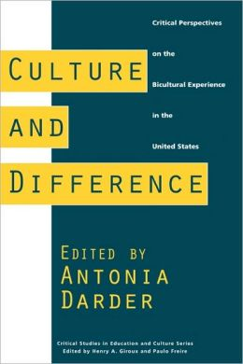
The yearning to remember who we are is not easily detected in the qualitative dimensions of focus groups and ethnographic research methods; nor is it easily measured in standard quantified scientific inquiry. It is deeply rooted, obscured by layer upon layer of human efforts to survive the impact of historical amnesia induced by the dominant policies and practices of advanced capitalism and postmodern culture. Darder's introduction sets the tone by describing the formation of "Warriors for Gringostroika" and "The New Mestizas." In the words of Anzaldua, "those who cross over, pass over . . . the confines of the `normal.'" Critical essays follow by Mexicanas, poets, activists, and educators of all colors and persuasions. The collection coming out of the good work of the Southern California University system relates to all locales and spectrums of the human condition and will no doubt inspire excellent creativity of knowing and remembering among all who chance to read any part thereof.

http://www.barnesandnoble.com/w/women-intellectuals-modernism-and-difference-alice-gambrell/1110868418?ean=9780521556880

How do gender and race become objects of intellectual inquiry and evaluation? In this book Alice Gambrell examines the careers of a group of women intellectuals—Leonora Carrington, Ella Deloria, H.D., Zora Neale Hurston, and Frida Kahlo—whose scholarly rediscovery coincided with the rise of feminist and minority discourse studies in the academy. Gambrell offers new ways of thinking about the relationships between cultural studies, feminism and minority discourse within the ongoing reassessment of Modernism.

http://www.barnesandnoble.com/w/multicultural-jurisdictions-ayelet-shachar/1100960044?ean=9780521776745
Can the state respect cultural differences while protecting the rights of vulnerable group members, in particular women? Shachar argues that it is both theoretically needed and institutionally feasible. Rejecting prevalent solutions to this "paradox of multicultural vulnerability", Multicultural Jurisdictions argues for enhancing minorities' autonomy, while providing viable legal-institutional solutions to intra-group rights violation. This new "joint governance" approach reduces the injustice between minority groups and society, while enhancing justice within them. This book will interest students of political and social theory, law, religion, institutional design, and cultural and gender studies.

http://www.barnesandnoble.com/w/understanding-cultural-differences-edward-t-hall/1111884099?ean=9781877864070
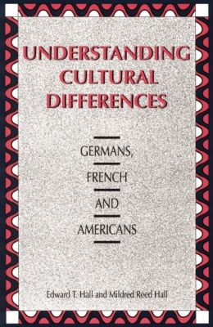
Human resource management, at home and abroad, means assisting the corporation's most valuable asset: its people. Understanding Cultural Differences: Germans, French and Americans contributes to this effort by explaining the cultural context in which corporations in Germany, France and the U.S. operate and how misunderstandings arise among employees from each country. Based on interviews with top German, French and American executives and on extensive research in intercultural relations, Edward T. Hall and Mildred Reed Hall offer insights to each country’s unique approach to business and practical advice on day-to-day transactions in international business exchanges. Designed for Americans, Germans and French alike, this book examines all three countries both individually and in relation to each other, covering topics like concepts of time, communication styles, cultural values, psychological mindsets, stereotypes, business etiquette, and the physical distances between individuals when they interact. The Halls emphasize behavior you can expect in the social and business culture of each country, pointing out possible pitfalls in understanding and communication and offering insightful advice for coping. A model for cross-cultural analysis, Understanding Cultural Differences is a valuable guide for American, German and French business executives.
http://www.barnesandnoble.com/w/critical-social-theory-craig-j-calhoun/1101189168?ean=9781557862884
In this outstanding reinterpretation - and extension - of the Critical Theory tradition, Craig Calhoun surveys the origins, fortunes and prospects of this most influential of theoretical approaches. Moving with ease from the early Frankfurt School to Habermas, to contemporary debates over postmodernism, feminism and nationalism, Calhoun breathes new life into Critical Social Theory, showing how it can learn from the past and contribute to the future.

http://www.barnesandnoble.com/w/cross-cultural-dialogues-craig-storti/1110949531?ean=9781877864285
Culture affects everything we do: the simplest phrase can be so steeped in cultural context that even seemingly innocent exchanges between people are loaded with cultural differences waiting to expand into misunderstanding and tension. In response, Cross-Cultural Dialogues: 74 Brief Encounters with Cultural Difference offers a collection of 74 brief conversations between an American and people from other cultures, spanning nearly every major region of the world. Each dialogue is categorized as a social, workplace or business interaction and contains at least one breach of cultural norms, which the reader is then challenged to address. Even the most careful reader will be caught off guard by some of the dialogues' hidden subtleties. Storti is meticulous in his analysis of each dialogue, pinpointing not only the moment when the interaction goes wrong, but also identifying the cultural reasons behind each participant's point of view. Whether training others or adding to your own cultural awareness, Cross Cultural Dialogues is an excellent resource, encouraging readers to engage in the world and increase their multicultural understanding.

