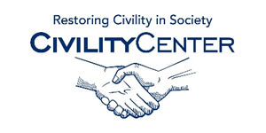Civility around the World

Culture and Civility Blogs
The institute for Civility in Government
http://www.instituteforcivility.org/blog/
Civility and the Civilized Man
http://proof-proofpositive.blogspot.ca/2015/01/civility-and-civilized-man.html
Saving Civility blog
http://savingcivility.com/blog/
Civility Partners LLC – Blog
http://civilitypartners.com/blog/
Teaching Civility in an F-word society
https://www.psychologytoday.com/blog/the-moment-youth/201206/teaching-civility-in-f-word-society
Cultures around the world
http://culturess.blogspot.ca/
Unique Cultures – Culture blog, wordpress
https://uniquecultures.wordpress.com/
The Culture-ist
http://www.thecultureist.com/2013/12/20/best-blogs-and-websites-of-2013/
Around the World blog
http://aroundtheworldblog.blogspot.ca/
For Culture’s sake
https://forculturessake.wordpress.com/

