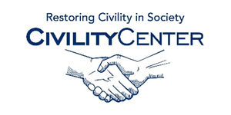Civility in Politics
Training
Institute for Civility in Government
http://www.instituteforcivility.org/who-we-are/what-is-civility/
The Civility Institute
http://civilityinstitute.com/
The Advocates Society
http://www.advocates.ca/new/advocacy-and-practice/institute-for-civility-and-professionalism.html
Political Correctness as Civility
http://crookedtimber.org/2004/01/29/political-correctness-as-civility/
Playing Nice
http://www.academia.edu/11274825/Playing_Nice_Modeling_Civility_in_Online_Political_Discussions
Institute for Civility in Government
http://www.woodforestpc.org/mission/civility/
Got Etiquette? Political Etiquette
http://gotetiquette.com/talking_politics_etiquette_article.html
Etiquette School of Oklahoma
http://www.esokla.com/
Etiquette Training with the Etiquette guy
http://wpic.typepad.com/wpic/2011/11/etiquette-training-with-the-etiquette-guy.html
Etiquette and Protocol Training
http://comlinks.com/polintel/pi070410.htm

