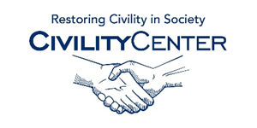Civility in Politics
Blogs
http://www.instituteforcivility.org/blog/
http://savingcivility.com/blog/
http://cf.telegram.com/submissions/blogs.cfm?category=Middle-aged%20Musings
http://opinionator.blogs.nytimes.com/2014/12/14/did-salaita-cross-the-line-of-civility/?_r=0
https://bullybloggers.wordpress.com/2014/08/18/civility-disobedience/
http://academeblog.org/2014/09/12/cucfa-statement-on-civility-and-academic-freedom/
http://www.newappsblog.com/2014/09/normalizing-civility-policing-critique-enforcing-silence-and-misunderstanding-collegiality.html
http://thepoliticalenvironment.blogspot.ca/2014/12/lack-of-civility-alert-jeff-wagner.html
http://thehill.com/blogs/pundits-blog/lawmaker-news/137527-some-historical-perspective-on-political-civility
http://theagenda.tvo.org/blog/agenda-blogs/getting-more-civility-politics

