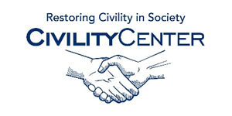Civility in Politics
Assessment and article links
http://urban.csuohio.edu/forum/events/pdf/11-28-11_civility_in_politics.pdf
http://wsm.wsu.edu/s/index.php?id=823
http://www.annenbergpublicpolicycenter.org/civility-in-the-house-of-representatives/
http://www.artsci.wustl.edu/~alambert/mutz.pdf
http://www.civilpolitics.org/content/putting-interventions-to-the-test-a-comparison-of-five-techniques-to-reduce-partisan-hostility/
http://www.theparksimagegroup.com/2010/03/29/politics-and-the-loss-of-civility/
http://www.academia.edu/4913272/Political_Civility_Another_Illusionistic_Ideal
http://www.goodradioshows.org/peaceTalksL19-20.html
http://www.gallup.com/poll/114121/Few-Americans-Perceive-Civil-Tone.aspx
http://www.jsonline.com/news/opinion/a-plea-for-a-return-to-civility-in-politics-785ginh-154283445.html
http://www.aacu.org/liberaleducation/2013/fall/leskes
http://onlinelibrary.wiley.com/doi/10.1111/j.1083-6101.2005.tb00252.x/full

