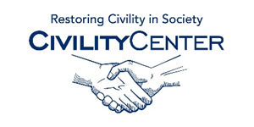Civility in Politics
Articles
http://www.thedailybeast.com/articles/2014/04/11/lack-of-civility-is-destroying-washington-d-c.html
http://ideas.time.com/2012/10/16/civility-in-elections-is-overrated/
http://www.diversityinc.com/diversity-management/the-culture-of-bullying-loss-of-civility-at-school-work-politics/
http://sites.allegheny.edu/civility/
http://www.huffingtonpost.com/lauren-maddox/building-a-washington-tha_b_6723148.html
http://journalistsresource.org/studies/society/news-media/journalists-public-views-incivility-political-news-discourse?wpmp_switcher=mobile
http://newscenter.berkeley.edu/2012/07/13/disrespect-in-politics-is-civility-possible/
https://osf.io/qe9zp/statistics/
http://www.history.org/almanack/life/manners/rules2.cfm
http://theconservativetreehouse.com/2015/01/21/jaw-dropping-hypocrisy-president-obama-calls-for-political-civility-then-immediately-claims-i-won/

