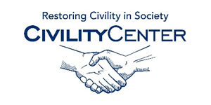Civility at work
Books
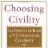
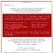
Choosing Civility: The Twenty-five Rules of Considerate Conduct Paperback – Nov 8 2003
http://www.amazon.ca/Choosing-Civility-Twenty-five-Considerate-Conduct/dp/0312302509
by P. M. Forni (Author)

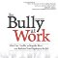
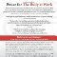
The Bully at Work, 2E: What You Can Do to Stop the Hurt and Reclaim Your Dignity on the Job Paperback – Jun 1 2009
http://www.amazon.ca/The-Bully-Work-2E-Reclaim/dp/1402224265/ref=pd_sim_b_2?ie=UTF8&refRID=148BX2K79WMTTDY8D3XG
by Gary Namie PhD (Author), Ruth Namie PhD (Author)
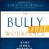
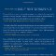
The Bully-Free Workplace: Stop Jerks, Weasels, and Snakes From Killing Your Organization Hardcover – May 24 2011
http://www.amazon.ca/The-Bully-Free-Workplace-Weasels-Organization/dp/0470942207/ref=pd_sim_b_1?ie=UTF8&refRID=0AQBA5FXE24D1FRCA3N3
by Gary Namie (Author), Ruth F. Namie (Author)

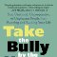
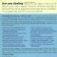
Take the Bully by the Horns: Stop Unethical, Uncooperative, or Unpleasant People from Running and Ruining Your Life Paperback – Sep 9 2003
http://www.amazon.ca/Take-Bully-Horns-Uncooperative-Unpleasant/dp/0312320221/ref=pd_sim_b_5?ie=UTF8&refRID=0Y2PCCVZN2JZNN9WK0CT
by Sam Horn (Author)

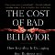
The Cost of Bad Behavior: How Incivility Is Damaging Your Business and What to Do About It Hardcover – Jul 14 2009
http://www.amazon.ca/The-Cost-Bad-Behavior-Incivility/dp/1591842611/ref=pd_sim_b_2?ie=UTF8&refRID=144P4CBRN43BGHK5PPQM
by Christine Pearson (Author), Christine Porath (Author)

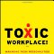
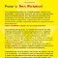
Toxic Workplace!: Managing Toxic Personalities and Their Systems of Power Hardcover – Apr 20 2009
by Mitchell Kusy (Author), Elizabeth Holloway (Author)

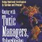
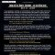
Coping with Toxic Managers, Subordinates ... and Other Difficult People: Using Emotional Intelligence to Survive and Prosper Paperback – Nov 17 2003
http://www.amazon.ca/Coping-Managers-Subordinates-Difficult-People/dp/0131409956/ref=pd_sim_b_2?ie=UTF8&refRID=0Z3J6VBMZDP0ZJK1WSF7
by Roy H. Lubit (Author)

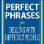
Perfect Phrases for Dealing with Difficult People: Hundreds of Ready-to-Use Phrases for Handling Conflict, Confrontations and Challenging Personalities Paperback – Sep 6 2007
by Susan Benjamin (Author)
http://www.amazon.ca/Perfect-Phrases-Dealing-Difficult-People/dp/0071493042/ref=pd_sim_b_2?ie=UTF8&refRID=0DP35NRXCH7F40B3H01V

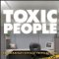
Toxic People: Decontaminate Difficult People at Work Without Using Weapons Or Duct Tape Hardcover – Sep 21 2007
http://www.amazon.ca/Toxic-People-Decontaminate-Difficult-Without/dp/0470147687/ref=pd_sim_b_7?ie=UTF8&refRID=0DP35NRXCH7F40B3H01V
by Marsha Petrie Sue (Author)
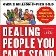
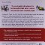
Dealing with People You Can’t Stand, Revised and Expanded Third Edition: How to Bring Out the Best in People at Their Worst Paperback – Jun 13 2012
http://www.amazon.ca/Dealing-Can-2019t-Revised-Expanded-Edition/dp/0071785728/ref=pd_sim_b_5?ie=UTF8&refRID=0DP35NRXCH7F40B3H01V
by Dr. Rick Brinkman (Author), Dr. Rick Kirschner (Author)

