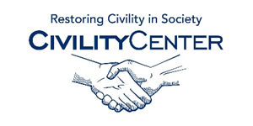Civility at School
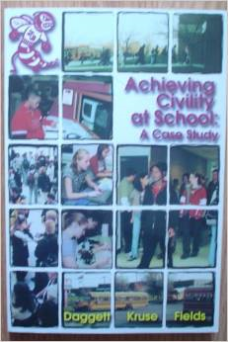
Achieving civility at school:
A case study (An ICLE best practices book) Paperback – 2000
Willard R Daggett (Author)
Achieving civility at school is a case study done by Willard Daggett and his associates Benedict Kruse and Gary Fields. A detailed post-Columbine analysis of school civility and violence prevention, the study concluded: "Peace happens as a way of life; enforcement is not real peace." This book will help make your school a safe, respectful, and engaging place for all students.

The How Rude! Handbook of School Manners for Teens: Civility in the Hallowed Halls (How Rude Handbooks for Teens...
Sep 15, 2004
by Alex J. Packer
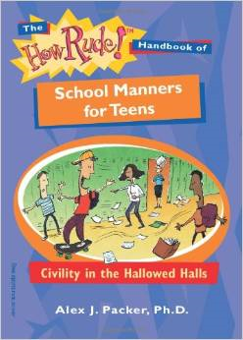
What counts as rude behavior in school? What can you do when a teacher is rude? What’s the best way to handle bullies and bigots?
Here’s sound advice (touched with humor) for teens who want to make school more bearable.

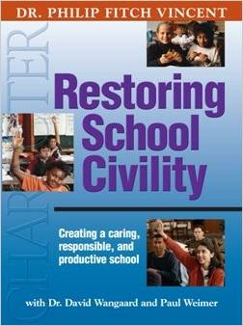
Restoring School Civility: Essential for the Success of No Child Left Behind
Dr. Philip Fitch Vincent (Author)
The most prolific trainer of character and civility in schools now shares the heart and spirit of his quintessential plan for success! This comprehensive and long-awaited primer defines the need for civility in our schools, and outlines the steps by which any school can achieve a productive, civil and caring climate. Dr. Vincent's clearly-defined approaches are supported by case studies and action plans that include: Providing consistency for young children Using consistent practices and procedures How good habits build civility Promoting civility through literature and narratives Developing a mission statement on civility Promoting civility through service

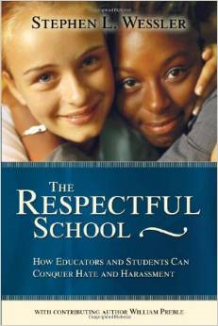
The Respectful School: How Educators and Students Can Conquer Hate and Harassment Paperback – October 29, 2003
Stephen Wessler (Author), William Preble (Author)
Not a school day goes by without some student facing teasing or slurs in the hallways, classrooms, or playgrounds. Left unchecked, such harassment can escalate and create an oppressive school climate where stress and fear overpower learning. In The Respectful School, Stephen L. Wessler and contributing author William Preble vividly describe how words can hurt--both emotionally and physically--and how words can heal. Drawing on his experience as a former state prosecutor overseeing hate crime enforcement and as current director of the Center for the Prevention of Hate Violence, Wessler discusses what educators can do to create a truly respectful environment that promotes positive interactions among staff and students.

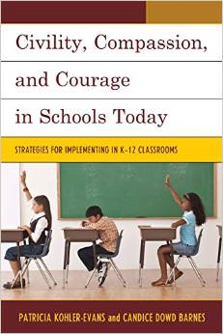
Civility, Compassion, and Courage in Schools Today: Strategies for Implementing in K-12 Classrooms
Patricia Kohler-Evans (Author), Candice Dowd Barnes (Author)
Over the past two decades, and perhaps even before the “No Child Left Behind Act,” policy makers and others have managed to drain civility, compassion, and courage from everyday classroom instruction. We have grown to become an educational system that is almost solely focused on academics at the expense of teaching to the whole child. Civility, Compassion, and Courage in Schools Today argues that civility, compassion and courage are absolutely essential to foster good citizenship—to encourage and motivate students to action—to take on the perspectives of others, and to see how they can become productive members in an ever changing global community. Using the authors’ “Model of Influence,” a four level hierarchy, they suggest that students can be taught to be more civil, compassionate, and courageous, even when facing adversity, and can move from developing a consciousness about these attributes into embracing influence and taking bold action.

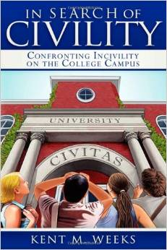
In Search of Civility: Confronting Incivility on the College Campus
Kent M. Weeks
"In Search of Civility" provides relevant context for the complex civility challenges facing students, faculty, and administrators. Colleges can play an important role in instilling civility among their students in their academic and social lives. Civil conduct requires treating others the way one wishes to be treated as well as a sense of duty and responsibility to the community.
By raising questions, "In Search of Civility" challenges students to make the connection between the morals and values they claim to hold and the practical implications of those values expressed through acts of civility in every part of their lives.
Weeks draws on a wide range of experiences--as teacher of undergraduate and graduate students at George Peabody College, Vanderbilt University, and as legal advisor to colleges throughout the US.

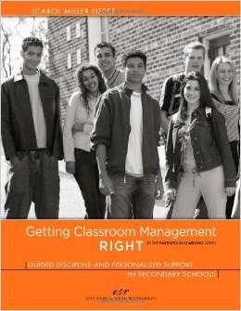
Getting Classroom Management RIGHT: Guided Discipline and Personalized Support in Secondary Schools (In the Partners in Learning Series)
Carol Miller Lieber
Getting Classroom Management RIGHT provides resources specifically designed for teachers who work with adolescents and want to create learning environments that foster fairness, mutual respect, student accountability, and self-discipline. It offers research-based tools, skills, and guiding principles that enable secondary teachers to organize and manage their classrooms for optimal learning; prevent most disruptive behaviors; diagnose and respond to problematic behaviors efficiently; and provide the right kinds of accountable consequences and supportive interventions that will help reluctant and resistant students to turn around their behavior.

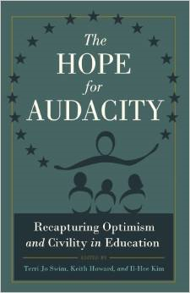
The Hope for Audacity: Recapturing Optimism and Civility in Education (Critical Education and Ethics)
Terri Jo Swim (Editor), Keith Howard (Editor), Il-Hee Kim (Editor
For far too long, public education had been under the shadow of terms such as failing schools, achievement gaps, and poor classroom management. While many publications have outlined these issues, the goal of this book is not to resonate despair but to illuminate our hopes and dreams for public education. For the authors of this book, having the audacity to hope for better public education means trusting teachers and children to engage in intellectual endeavors that advocate for the development of the whole person and active participation in a democratic community. This book will be a great resource for pre-service and in-service teachers, professors, administrators, and policy-makers in exploring a new pathway for educational reform.

Doing Civility: Breaking the Cycle of Incivility on the Campus
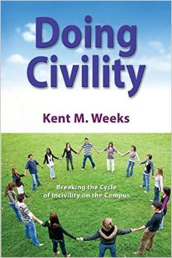
by Kent M. Weeks
Doing Civility: Breaking the Cycle of Incivility on the Campus, explores ways in which members of the college community can take proactive steps to break the cycle of incivility. Civility requires extending mutual respect to others, especially people with different values, beliefs, and ideas. It also involves a civic responsibility to strengthen the community.
Doing Civility dives into how civility can be applied in practical ways using real-life student stories.
Doing Civility is a companion book to In Search of Civility. Together, the two books provide sharp analysis for understanding civility on campus and in the workplace. Doing Civility incorporates interactive tools and exercises at the end of each chapter designed to help readers apply the concepts covered in the chapter. The tools and exercises are perfect for self-reflection or small group discussions.
Americans are trouble by the growing incivility they see in public life and in their interpersonal relationships. The modern college and university may offer the best and most effective forum for providing an education in civility for our future leaders. It’s time to do civility.
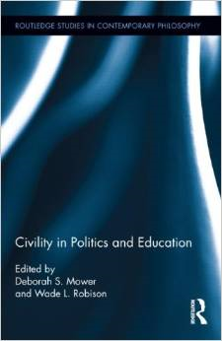
Civility in Politics and Education (Routledge Studies in Contemporary Philosophy)
Deborah Mower (Editor), Wade L. Robison (Editor)
This book examines the concept of civility and the conditions of civil disagreement in politics and education. Although many assume that civility is merely polite behavior, it functions to aid rational discourse. Building on this basic assumption, the book offers multiple accounts of civility and its contribution to citizenship, deliberative democracy, and education from Eastern and Western as well as classic and modern perspectives. Given that civility is essential to all aspects of public life, it is important to address how civility may be taught. While much of the book is theoretical, contributors also apply theory to practice, offering concrete methods for teaching civility at the high school and collegiate levels.

Books reference website: http://www.amazon.com/s/ref=sr_pg_2?rh=n%3A283155%2Ck%3Acivility+at+school&page=2&keywords=civility+at+school&ie=UTF8&qid=1423721315

