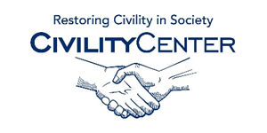Civility around the World

Assessments
http://www.culturalq.com/tmpl/assessments/professional.php
http://www-03.ibm.com/industries/ca/en/education/k12/lessonplans/lp_culture_k_2.pdf
http://blog.discoveryeducation.com/nunofkaraujo/
http://www.learningtogive.org/lessons/unit6/
http://www.learnnc.org/lp/pages/3024
http://www.researchgate.net/publication/258423330_Lessons_from_around_the_world_how_policies_politics_and_cultures_constrain_and_afford_assessment_practices
https://www.teacherspayteachers.com/Product/Cultures-around-the-World-A-Research-Project-1336576
http://eric.ed.gov/?id=EJ694937
http://www.businessinsider.com/communication-charts-around-the-world-2014-3
http://marciaconner.com/resources/learning-culture/

