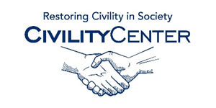Civility and family
Civility and family books
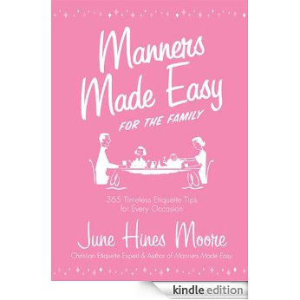

Manners Made Easy for the Family: 365 Timeless Etiquette Tips for Every Occasion [Kindle Edition]
June Hines Moore (Author)

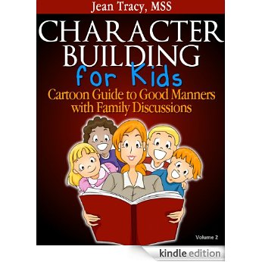

Character Building for Kids: Cartoon Guide to Good Manners with Family Discussions [Kindle Edition]
Jean Tracy (Author)

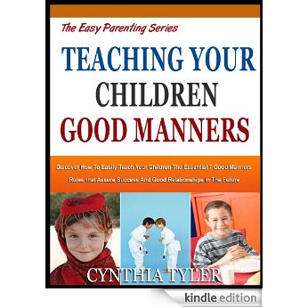

TEACHING YOUR CHILDREN GOOD MANNERS: Discover How To Easily Teach Your Children The Essential 7 Good Manners Rules That Assure Success And Good Relationships ... Future (The Easy Parenting Series Book 5) [Kindle Edition]
Cynthia Tyler (Author)

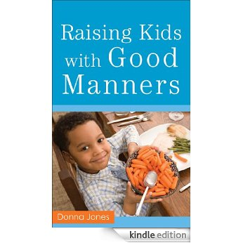

Raising Kids with Good Manners [Kindle Edition]
Donna Jones (Author)

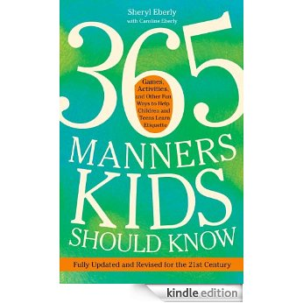

365 Manners Kids Should Know: Games, Activities, and Other Fun Ways to Help Children and Teens Learn Etiquette [Kindle Edition]
Sheryl Eberly (Author)

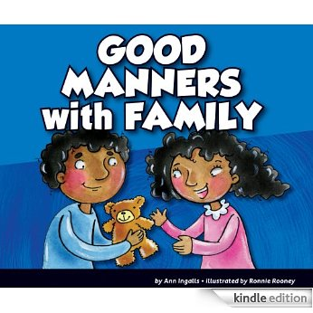

Good Manners with Family [Kindle Edition]
Ann Ingalls (Author), Ronnie Rooney (Illustrator)

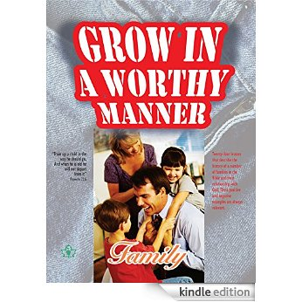

Grow in a Worthy Manner: Family [Kindle Edition]
Marco de Mello (Author)

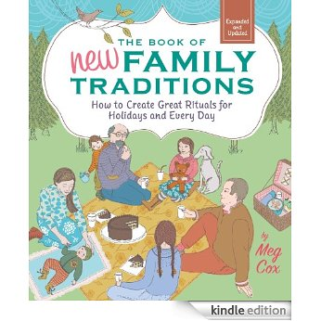

Click to open expanded view
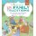

The Book of New Family Traditions (Revised and Updated): How to Create Great Rituals for Holidays and Every Day [Kindle Edition]
Meg Cox (Author)

