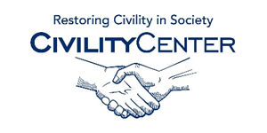Civility and family

Civility and family/home blogs
http://www.modern-manners-and-etiquette.com/manners-blog.html
http://www.practicaletiquette.com/etiquette-blog.html
http://www.huffingtonpost.com/lisa-mirza-grotts/family-etiquette_b_1026800.html
http://www.nepafamily.com/blogs/defining-manners
http://www.goodmannersmom.blogspot.ca/
http://theetiquettefactory.blogspot.ca/
http://life.familyeducation.com/manners-and-values/parenting/34452.html
http://www.valleyfamilyfun.ca/index.php/blog/etiquette-101-kids/
http://mondaynightmanners.blogspot.ca/
http://provocativemanners.blogspot.ca/

