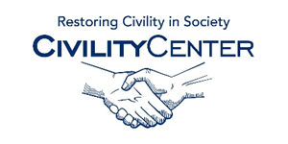Civility and family

Civility and family/home articles
http://www.emilypost.com/home-and-family-life
http://www.familytime.com/ShowArticle.aspx?ArticleId=718
http://ezinearticles.com/?Common-Family-Dining-Etiquette-Mistakes&id=2868553
http://www.meltdata.com/articles/death-in-the-family-etiquette-6.html
http://etiquetteadvantage.ca/
http://ezinearticles.com/?10-Table-Manners-Every-Family-Should-Practice&id=18490
http://www.goodhousekeeping.com/family/etiquette/
http://www.articlesnatch.com/topic/family+dining+etiquette#.VN5EgPYtHak
http://www.startribune.com/lifestyle/relationship/287987341.html

