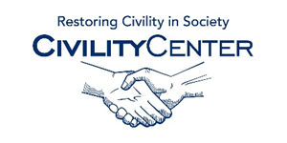Civility and family

Civility and family/home training
http://etiquette-ny.com/family-dining/
http://www.a-to-z-of-manners-and-etiquette.com/manners-and-etiquette-for-children.html
http://www.etiquetteoutreach.com/parents_children_etiquette_manners_dining/
http://www.a-better-child.org/page/801578
http://www.elizabethetiquette.com/
http://tiffanynielsen.com/services/etiquetteandmannersclasses/
http://www.ocfamily.com/t-Child_etiquette_training_manners_social_behavior0911.aspx
http://www.beinstitute.com/clients/individuals-families/
http://ctkidsandfamily.com/advertisers_details.php?Etiquette-Protocol-Training-for-Children-Adolescents-1046
http://www.businesstrainingworks.com/onsite-training-courses-directories/etiquette-training-and-business-etiquette-training-courses-directory

