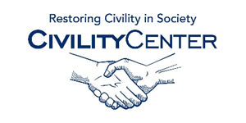Civility and Community

Assessments/Articles
http://www.ncbi.nlm.nih.gov/pubmed/23066695
Getting better and staying better: assessing civility, incivility, distress, and job attitudes one year after a civility intervention.
http://www.americannursetoday.com/civility-starts-with-you/
Civility Starts with you
http://ccncce.org/articles/teachable-moments-of-civility-in-every-classroom/
Teachable Moments of Civility in Every Classroom
http://www.researchgate.net/publication/232253271_Getting_better_and_staying_better_Assessing_civility_incivility_distress_and_job_attitudes_one_year_after_a_civility_intervention
Getting better and staying better: Assessing civility, incivility, distress, and job attitudes one year after a civility intervention
http://character.org/about/audiences/community/
Variety of assessments and tools

